Output:

Screenshot Query 1

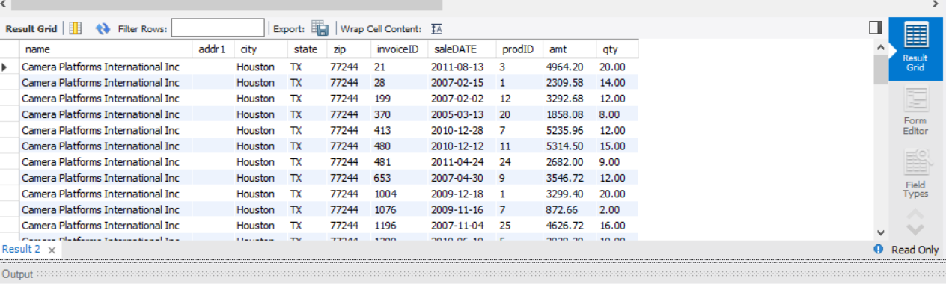

Screenshot Query 2

